- . The effects of a tornado and salvage-logging on ground beetles
Abstract
Forest ecosystems are periodically affected by natural disturbance such as windthrow, which opens the canopy and causes changes to vegetation and microclimates. Forest managers often harvest fallen trees affected by windthrow in a process called salvage logging, but this practice may have long-term effects on biodiversity. We studied how a tornado event followed by salvage-logging affected forest health. To do this, we used ground beetles (Coleoptera: Carabidae) as indicators, due to their sensitivity to changes in microclimate, woody debris, and vegetation. We also investigated species-specific functional traits of ground beetles relating to sensory strategy, locomotion, and microclimatic preferences, which could relate to fitness within disturbed habitats. We hypothesized that alpha-diversity (both taxonomic and functional) would increase in windthrow and salvage-logged forest initially (3 years) after disturbance due to immigration of open-habitat species, but that salvage-logging would result in a decline in diversity by 10 years due to reduced woody-debris. We collected ground beetles in windthrow, salvaged, and forest plots at Powdermill Nature Reserve, Westmoreland County, Pennsylvania during the growing seasons of 2015 and 2022, identified ground beetles to species, and measured 10 functional traits of each species. We found 47 species, most of which were either forest-specialists (20) or habitat generalists (24), and few which were open-habitat specialists (2). Number of ground beetle individuals spiked in salvaged areas in 2015. Species richness was higher in salvaged areas, but functional alpha-diversity did not differ between forest management treatments. However, ground beetle community composition differed between salvage-logging, windthrow, and undisturbed forest. Salvage-logging caused increases in species with larger eyes and longer rear trochanters relative to body length. Salvage-logging also caused a temporary increase in species with flight capability, which disappeared by 2022. Thus, short- and long-term impacts of salvage-logging following a tornado affected both the taxonomic and functional metrics of ground beetle biodiversity.

Introduction
Natural disturbances, including fires, windstorms, floods, droughts, and insect outbreaks, have occurred in forests for millions of years (Lindenmayer et al. 2012). In forests of the eastern United States, wind from strong storms such as hurricanes, derechos (straight-line windstorms), and tornados is a dominant disturbance regime (Fischer et al. 2013). When windstorms knock down canopy trees, the increased sunlight reaching the understory and forest floor can induce environmental changes. Soil temperature extremes can increase, moisture can change depending on reduced evapotranspiration but increased summer temperature, and leaf litter depth can decrease due to faster decomposition (Greenberg and Forrest 2003, Urbanovicova et al. 2014). Although canopy trees are often killed, a windstorm leaves much of the forest structure intact, especially in the understory. The organisms and structures left behind by the disturbance are called biological legacies, and include understory plants, remaining trees, woody debris, tip-up mounds from uprooted trees, seeds, root systems, soils, and surviving animals (Lindenmayer et al. 2012, Perry and Herms 2019). Because understory shrubs, herbaceous plants, and tree advance regeneration often survive the windstorm, and because sunlight levels increase in the understory, this results in increased growth rates of these preexisting plants (Barber and Widick 2017, Perry et al. 2018). Furthermore, woody debris from the disturbance decomposes over time, and structures such as tip-up mounds and pits create areas for variable plant communities (Peterson and Leach 2008). Thus, forests change over time following a windstorm.
Harvesting the fallen trees after a natural disturbance is called salvage-logging, and this management practice is a common response to windstorms (Lindenmayer et al. 2012). Salvage-logging can help landowners recover the economic value of the fallen trees, or it may be motivated towards reducing the risk of fire and insect outbreaks, or safety hazard (Thorn et al. 2014, Perry and Herms 2019). Salvage-logging uses machinery to harvest downed trees, and sometimes residual standing trees. Salvage-logging removes or alters some of the legacies left by the windstorm, including the understory shrubs and herbs, tree advance regeneration, woody debris, and hollow trees (Slyder et al. 2020, Schammel et al. 2025). It can also cause soil compaction, depending on the conditions (McNabb et al. 2001). An increase in bare soil in salvage-logged areas, in combination with increased sunlight, can promote the growth of shade-intolerant tree species, as well as new species of herbaceous plants and shrubs (Elliott et al. 2002, Slyder et al. 2020, Spicer et al. 2023). Thus, salvage-logging alters habitat elements, benefitting some species while harming others. Insect populations are of particular importance, due to their place in food webs and the threats occurring to insects globally (Wagner 2019). While salvage-logging has been shown to affect multiple taxa of insects, most studies focus on short-term affects, less than 5 years after disturbance (Thorn et al. 2018). Conservationists would benefit from information on the long-term impacts of salvage-logging on insects, which would enable them to make informed management decisions.
To understand how insect biodiversity is affected by forest management, an indicator taxon can be used, which is a starting point for characterizing the response of the insect community (Langor and Spence 2006). Ground beetles (Coleoptera: Carabidae) are useful indicators because they are taxonomically well known, respond quickly to abiotic and biotic conditions, and are sensitive to forest disturbances (Koivula 2011). Some species of ground beetles are adapted to mature forests, whereas others are adapted to early-successional habitats like fields and clearings, and as a result, species composition is sensitive to forest disturbance (Silverman et al. 2008, Lambeets et al. 2008, Lundgren and McCravy 2011). Within forests, ground beetle communities can differ based on predominate tree species, managed vs. old-growth forest, and forests varying in height and density of ground-level vegetation (Werner and Raffa 2000, Phillips and Cobb 2005, Browne et al. 2014, Perry et al. 2018). Thus, the occurrence and species composition of ground beetles can indicate fine-scale differences in habitat.
Following forest disturbance, species respond to changes in environmental conditions, which often results in an influx of new species and decline in some resident species. After canopy gaps open and early successional plants begin to grow, guilds of open-habitat and generalist ground beetles typically disperse to the disturbed area. This group, including certain species of Amara, Anisodactylus, Harpalus, and Chlaenius, may immediately increase following disturbance, or may take a few years to locate the site, depending on surrounding landscape structure (Sklodowski and Garbalinska 2011, Lee et al. 2017, Barber and Widick 2017). While open-habitat species increase after disturbance, there is also a decline of forest-adapted ground beetles, often over multiple years (Riley and Browne 2011). For example, in Minnesota, jack pine stands that were wind-disturbed or salvaged-logged 1-3 years prior had lower numbers of Pterostichus pensylvanicus LeConte, Pterostichus coracinus (Newman), and Sphaeroderus lecontei Dejean than undisturbed sites (Gandhi et al. 2008). In a pine forest in Poland, forest-specialists decreased in proportional abundance over a six-year period following a tornado disturbance (Sklodowski and Garbalinska 2011). These observed decreases in forest-adapted ground beetles after disturbance could be caused by a variety of factors, including changes to the ground-level microclimate (Greenberg and Forrest 2003). Salvage-logging, because it is implemented soon after a natural disturbance, may have greater impacts on ground beetles than windthrow alone. Furthermore, the effects of salvage-logging on ground beetles could last decades, due to the removal of long-lasting biological legacies such as decaying logs (Gore and Patterson III 1986). Because climate change might alter the frequency and/or severity of windstorms (Seidl et al. 2017), salvage-logging may continue to be a widespread practice, meaning that its long-term impacts deserve further study.
While much is known about how the taxonomic composition of ground beetle communities change after forest disturbance, less is known about how these disturbances may impact the functional diversity of beetles via changes in traits. Studies have documented that ground beetle species common in tornado-disturbed forests were smaller in size, incorporated plant material or seeds into their diets, and were capable of flight, compared to those characteristic of undisturbed forest (Sklodowski and Garbalinska 2011, Perry and Herms 2019). These traits likely relate to the ability of a species to disperse to a disturbed site, and to utilize new food resources such as seeds of herbaceous plants (Venn 2016, Baulechner et al. 2020). However, less is known about other ground beetle traits, and how they relate to survival, growth, and reproduction after a forest disturbance. Ground beetles exhibit trait syndromes (Fountain-Jones et al. 2015) associated with locomotion strategy, including surface-walking, pushing through leaf litter, burrowing, and climbing plants (Evans 1977, Erwin 1979, Forsythe 1991, Larochelle and Larivière 2003). Furthermore, carabid species have different sensory morphologies, including differences in compound eye size, eye shape, and antenna length. These morphologies relate to behavioral differences such as hunting strategy (visual, or tactile), shade preference, flight ability, and daily activity period (Bauer and Kredler 1993, Talarico et al. 2007, 2011). Ground beetle species also differ in their affinity towards water, and this physiological/behavioral trait plays an important role in habitat selection (Thiele 1977). Because forest disturbance can affect sunlight, leaf litter and vegetation cover, soil density, woody debris volume, prey types, and water table height (McNabb et al. 2001, Urbanovicova et al. 2014, Slesak et al. 2014, Barber and Widick 2017), these habitat changes could favor species with traits that confer a fitness advantage. Research is needed to determine if the effect of forest disturbance on ground beetles is mediated by their species-specific traits.
Our goal was to determine the long-term impacts of salvage-logging after a tornado, and to investigate whether the combination of these two disturbances together affected insect biodiversity. To do this, we compared the taxonomic and functional diversity of ground beetle communities among undisturbed forest and forest impacted by unsalvaged windthrow and salvage-logged windthrow at three and ten years after a tornado. We predicted that the alpha-diversity (both taxonomic and functional) would be higher in forests impacted by windthrow and salvage-logging than undisturbed forest after only three years, due to the immigration of open-habitat species and the persistence of some forest species. After ten years, we predicted that salvaged plots would decline in alpha-diversity because of a depletion of biological legacies such as woody debris, which some species require (Pearce et al. 2003). We predicted that the species and trait composition of windthrow plots would be intermediate between those of salvaged and forest, due to the intermediate level of disturbance created by windthrow, which would recruit some open-habitat species while retaining some forest species. Finally, we predicted that salvaged plots would support a higher abundance of species with proportionally larger eyes, shorter antennae, and higher water affinity, traits which may increase fitness in a wetter habitat with higher sunlight (Bauer and Kredler 1993, McNabb et al. 2001).

Methods
Study site
Research was conducted at Powdermill Nature Preserve (PNR) in Rector, Westmoreland County, Pennsylvania (40° 9' 35.3052'' N, 79° 16' 18.3684'' W). This preserve was established as the field research station for the Carnegie Museum of Natural History in 1956 and is largely temperate deciduous forest. The annual precipitation for the years 2012-2022 was between 114 and 178 cm (45 and 70 in.) with a mean of 135 cm (53 in.) (weather station: USC00362183) (“National Centers for Environmental Information: Past Weather” 2012-2022). In June 2012, a tornado uprooted or snapped many canopy trees in two large areas of the forest, each about 120 × 480 m (Figure 1). These two areas are on north- or northwest-facing slopes, which were dominated by maple (Acer sp.), tuliptree (Liriodendron tulipifera L.), and black cherry (Prunus serotina Ehrh.) (Murphy et al. 2015), with an understory of predominately spicebush (Lindera benzoin L.) (Calinger et al. 2015). The tornado created patchy areas of downed and residual standing trees, with canopy openness varying from 25-90% (Slyder et al. 2020). The elevation of the impacted area ranges from around 503 m to 533 m (1650 ft. to 1750 ft). The Laurel Run river is found along the west side of the study area.

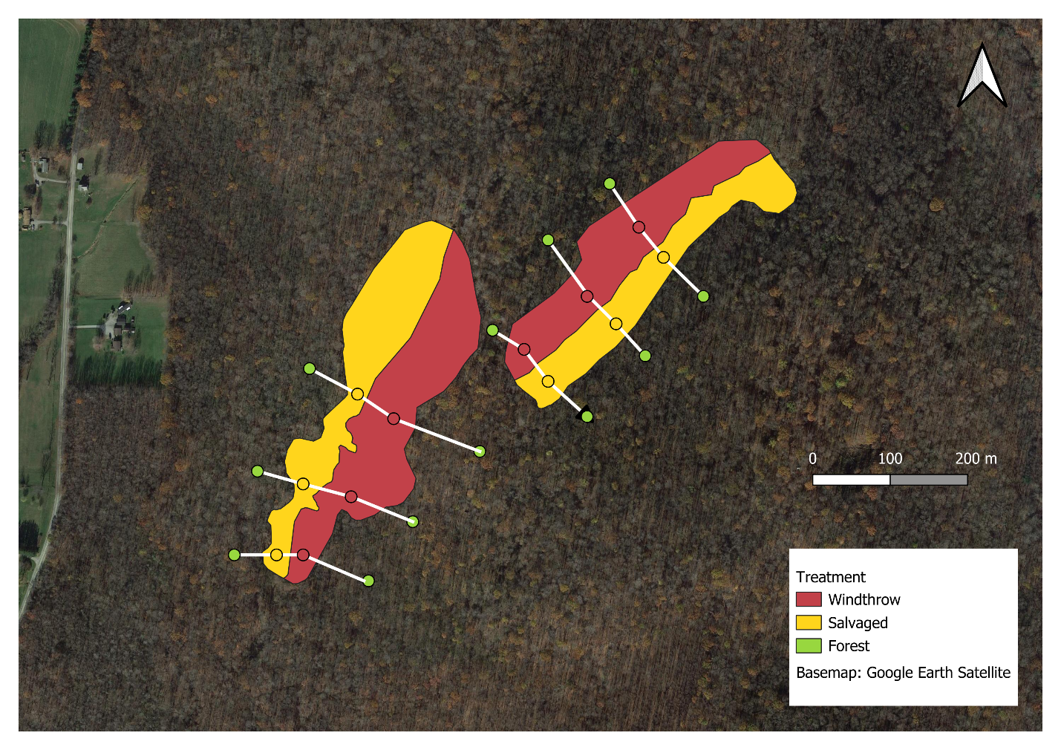
Figure 2.1. Map of the study area. The study was located at Powdermill Nature Reserve in Rector, Westmoreland County, Pennsylvania. Red shading represents forest affected by the tornado but left unsalvaged, whereas yellow shading represents forest affected by the tornado and subsequently salvage-logged. Colored dots are drawn in the plot locations, where pitfall traps were installed. Locations of plots have been slightly adjusted on this map to coincide with shapefiles of the shaded areas. White lines connecting the plots indicate the transects, which span the forest disturbances and extend into the undisturbed forest.
From mid-summer through winter of 2013, half of each wind-disturbed area was salvage-logged using intensive practices that included heavy machinery, roads, and skid trails to remove both fallen and residual standing trees. In 2015, three transects were established across each area of forest impacted by the tornado (total 6 transects) (Figure 2.1). Transects were established across the windthrow and salvaged disturbances that extended ≥50 m into the surrounding undisturbed forest on each side. Along each transect, four plots were established: 1) one plot in the tornado-affected forest which was not salvage-logged (hereafter: windthrow); 2) one in the tornado-affected forest which was then salvage-logged (hereafter: salvaged), and two in the surrounding undisturbed forest (hereafter: forest). This resulted in a sample size of 24 plots, wherein all data collection occurred.

Ground beetle sampling and identification
Ground beetles were sampled using unbaited barrier pitfall traps in 2015 and 2022, representing three and ten years post-tornado (two and nine years post-salvage-logging). Pitfall traps preferentially collect insects that are more active and mobile, and consequently the number of ground beetles caught in pitfalls is reported as activity-abundance (Gandhi et al. 2008). Barrier pitfall traps consisted of two pairs of plastic cups (each pair having an inner 500 mL cup and an outer 1 L cup) which were placed into the ground so that the lip of the cup was flush with the ground surface. The two pairs of cups were placed 1 m from each other, and garden edging (Suncast® eco edge) was placed between them to create a barrier. Cups were filled with approximately 4 cm of propylene glycol (recreational vehicle and marine antifreeze, Peak Company Old World Industries, Clear Lake, Texas) with a few drops of detergent. Masonite board (100 cm²) was placed at 3 cm above each cup to prevent flooding from rain. Steel hardware cloth was secured over cups using 30 cm stakes to limit mammal disturbance.
Pitfall trap sampling was conducted continuously over the growing seasons in 2015 and 2022. Trap catch was collected every two weeks, and cups were refilled with propylene glycol. In 2015, pitfall traps were installed on 27-28 May, and samples were collected on 9-10 June, 24-25 June, 8 July, 22 July, 5 August, and 17 August. In 2022, traps were installed on 1-2 June, and samples were collected on 15 June, 29 June, 13 July, 27 July, 11 August, and 23 August. Trap catch was collected by pouring the sample through a fine mesh strainer and storing the contents in a specimen cup with 70% ethanol until sorting and identification.
Ground beetles were identified to species using taxonomic keys (Lindroth 1961, Freitag 1969, Bousquet 2010, Bousquet and Messer 2010, Hunting 2013, Harden and Guarnieri 2017). Nomenclature followed Bousquet (2012). Species vouchers were deposited at the C. A. Triplehorn Insect Collection (OSUC), Museum of Biological Diversity, The Ohio State University, Columbus, Ohio where each specimen was given a unique identifier label (Table B.1).

Trait measurements
We selected eight morphological traits that have previously been shown to relate to habitat preference (Table 2.1) (Fountain-Jones, Baker, and Jordan 2015). These traits are body length, antenna length, eye protrusion, eye length, pronotum width, abdomen width, rear leg length, and rear trochanter length. Traits were measured under a dissecting microscope using an ocular micrometer to the nearest 0.1 mm. For each species, traits were measured on up to six individuals, three males and three females (Fountain-Jones, Baker, and Jordan 2015), although we did not achieve this number for rare species. The six individuals were chosen in a way that attempted to encompass the intraspecific variation in body size observed for the species. Most (185/202) specimens used for trait measurement were collected at Powdermill Nature Reserve, but a few (17/202) measured specimens were collected in Erie and Cuyahoga counties, Ohio (Table B.1). These specimens were used to supplement the sample size when less than six measurable individuals were collected at Powdermill. To control for variation in beetle body size, relative measurements of all morphological traits were calculated as their ratio to body length for each individual (Ribera et al. 2001), and thus all results of morphological traits pertain to traits in relation to body length. Trait measurements were then averaged across individuals of a species to calculate species-specific means.
In addition to morphological traits, traits related to flight capability, water affinity, and forest affinity were collected from the literature (Larochelle and Larivière 2003). Flight capability was coded as 1 if the species is flight-capable, 0 if the species is flight-incapable, and 0.5 if the species exhibits wing dimorphism. Water affinity was coded as 0 for xerophilous species, 1 for hygrophilous species, and 0.5 for intermediate species. Water affinity was treated as a physiological trait, because ground beetle species often have consistent humidity preferences in behavioral studies (Thiele 1977). Forest affinity was coded as forest-specialist, open-habitat, or generalist (meaning the species is found in forest clearings or in both forest and open habitats). Because only two species we found were recorded as open-habitat species in the literature, we pooled generalist and open-habitat species for the statistical analysis.

Table 2.1. Measured morphological traits and literature-based traits used in this study, and their connections to habitat variables that could be impacted by forest disturbance. The columns are trait, connection to habitat, and references.

Trait | Connection to habitat | References
Body length (mm) | Shorter body length was found for ground beetles caught in wind-disturbed forests, relative to undisturbed forests. Body length is correlated with many other morphological traits. | (Barton et al. 2011, Sklodowski and Garbalinska 2011)
Antenna length (mm) | Tactile hunter species, which rely on sense of touch more than vision, tend to have longer antennae. Longer antenna length relative to body length was found for ground beetles caught under a tree, versus in the open. | (Bauer and Kredler 1993, Barton et al. 2011)
Eye protrusion (mm) | A greater eye protrusion was found in a tree-climbing ground beetle, and it may allow partial overlap in the frontal visual field. However, greater eye protrusion might prevent a ground beetle from moving through thick vegetation or soil. | (Talarico et al. 2007)
Eye length (mm) | Diurnal ground beetle species and/or those adapted to open environments tend to rely on vision for predator avoidance or prey detection, and thus might have longer eyes. | (Talarico et al. 2007)
Pronotum width (mm) | A proportionally wider pronotum can be found in robust-bodied beetles, which tend to be found within open habitats. A narrow pronotum can be an adaptation to reaching prey within hard-to-reach soil crevices or snail shells. A narrow pronotum may also be related to the beetle having an unobstructed view behind its eyes. | (Thiele 1977, Forsythe 1991, Barton et al. 2011)
Abdomen width (mm) | Similar pattern to pronotum width, with species having proportionally wider abdomens tending to be found in open habitats. | (Barton et al. 2011)
Rear leg length (mm) | Open habitats seem to favor ground beetle species with shorter legs relative to body length. Ground beetles with longer legs may be weaker at pushing through dense substrates. | (Forsythe 1991, Barton et al. 2011)
Rear trochanter length (mm) | The rear trochanter connects to the femur of the rear leg. Ground beetles have a bean-shaped rear trochanter that allows them to move between narrow crevices between bark, leaf litter, or soil. The muscle in the rear trochanter allows the rear leg to create a force in the dorsal direction, which expands the space and allows the beetle to move through constricted areas. The trochanter is longer, on average, in species that push themselves through soil and underneath leaf litter. It is shorter in species that walk or run above the surface of the substrate. | (Forsythe 1991, Talarico et al. 2007)
Flight capability (range: 0-1) | Flight-capable species (macropterous and with fully developed flight musculature) can exploit patchy, temporary habitats. Conversely, flight incapable species may have higher fitness within stable habitats. | (Ribera et al. 2001, Venn 2016)

Continued

Table 2.1 Continued
Trait | Connection to habitat | References
Water affinity (range: 0-1) | Habitats vary in the saturation of the substrate with water, and water preference varies between ground beetle species, with some species found near riverbanks or other bodies of water, others found in moist leaf litter, and others found in dry soil. A preference for low humidity may be related to overwintering within tree stumps and logs, versus in the soil. | (Thiele 1977)
Forest affinity (forest specialist, eurytopic, or open-habitat) | Some ground beetle species tend to be caught in forests, underneath trees, whereas other species tend to be caught in fields, prairies, pastures, and other open habitats. | (Silverman et al. 2008)

Forest floor environment
Environmental variables on the forest floor were quantified to assess differences among windthrow, salvaged, and undisturbed forest. Percentage canopy openness was measured using a spherical crown densiometer directly above the pitfall traps to assess light availability on the forest floor. Canopy openness was measured on 9-10 June in 2015, and on 1-2 June in 2022. Percentage cover of ground-level vegetation and percentage cover of leaf litter were estimated in two randomly selected 1 m² quadrats around each pitfall trap. Ground cover estimates were collected on 9 June and 7 July in 2015 and on 1-2 June and 13 July in 2022. Values from the two quadrats around each pitfall trap were averaged together for a site-level mean. Soil moisture was measured at three locations adjacent to each pitfall trap using a Dynamax Inc. (Houston, Texas) TH20 portable soil moisture meter with a Theta Probe ML2x sensor in 2015. Soil moisture measurements were taken biweekly when pitfall samples were collected, for a total of six dates per year. The 18 soil moisture readings at each plot were averaged together for a single mean for the year.

Statistical analysis
All analyses were conducted in R version 4.4.1 (R Core Team 2024). All code and development history that support these findings can be found in the GitHub repository: add link.
To determine if our sampling effort was adequate to characterize the ground beetle community, we used species accumulation curves (SACs) and Chao estimators. For each year and treatment, we created a SAC with number of sampled plots on the x-axis. This was implemented using the specaccum function in the R package ‘vegan’ with the ‘random’ setting, which finds the mean SAC by permuting the order of the plots (Oksanen et al. 2024, R Core Team 2024). The Chao1 estimator was used to estimate a lower bound on the true species richness of ground beetles (Chao and Chiu 2016). This estimator incorporates the number of singletons and doubletons to estimate the number of undetected species and was implemented using the function ‘ChaoSpecies’ in the R package ‘SpadeR’ (Chao et al. 2016).
Before calculating abundance metrics, we accounted for occasional loss of trap catch due to animal disturbance (Perry et al. 2018). Trap catches were standardized to correspond to a sampling effort of six 14-day trapping intervals. Any plots where trap catch was lost for one interval were corrected by dividing the trap catch by $\frac{5}{6}.$ We calculated total activity-abundance of ground beetles as the sum of the activity-abundances of all species at a plot. Furthermore, we decomposed total activity-abundance into two groups: the contribution from forest specialist species, and the contribution from species that are generalists or specialize in open-habitats (Larochelle and Larivière 2003). To investigate alpha-diversity at the plot level, we calculated species richness (number of species) and Shannon diversity using the package ‘HillR’ (Li 2018). Shannon diversity was calculated using the formula exp(-Σp_{i}ln(p_{i})), which is the same as the Hill number of order 1. This metric takes values between 1 and the species richness, depending on the degree to which the relative abundances are equal.
We conducted a principal components analysis (PCA) using morphological traits of ground beetles to identify key axes of variation (Swenson 2014). All continuous traits had already been standardized by dividing by body length. We centered each continuous trait to a mean of 0, scaled to a variance of 1, and ran the PCA using the function ‘prcomp’ in the R package ‘stats’ (R Core Team 2024). We removed the species Notiophilus aeneus (Herbst, 1806) from the PCA analysis because inclusion of this rare species, which has unusual morphology, noticeably changed the PC axes (Table B.3). After running the PCA, we added Notiophilus back into the analysis by centering and scaling its data using the previously-calculated scaling coefficients and then projecting the values onto the PC axes using the loading values.
We used trait data in combination with ground beetle counts to calculate functional alpha-diversity. We used the first four PC axes, which together explained 89% of the variance in the data, along with the categorical variables Water affinity and Flight capability, to calculate a Gower dissimilarity matrix between all ground beetle species in trait space using the package ‘FD’ (Laliberte et al. 2014). The categorical variables were treated as ordinal data and the ‘metric’ method was used to calculate dissimilarity, so that a wing dimorphic species would be counted as intermediate in its flight capability. After obtaining the dissimilarity matrix, we calculated functional alpha diversity for each plot by computing the intra-plot mean dissimilarity between pairs of species in trait space. Each calculation of dissimilarity between a pair of species was weighted by the product of the species’ relative abundances at the plot, so that more abundant species had a larger influence on functional alpha diversity (Swenson 2014). The calculation was carried out using the function “mpd” in the R package ‘picante’ (Kembel et al. 2010).
To investigate the average traits of ground beetles at each plot, we calculated community-weighted mean (CWM) trait values. The CWM is the average trait value of all species found at a plot, weighted by the species’ relative abundances. These were calculated for all functional traits, including water affinity and flight capability, using the function “functcomp” in the R package ‘FD’ (Laliberte et al. 2014).
We compared ground beetle communities among forest management treatments and years using linear mixed-effects models with the R package ‘lme4’ (Bates et al. 2015) and ‘lmerTest’ (Kuznetsova et al. 2017). Our response variables were total activity-abundance, activity-abundance of open-habitat and generalist species, activity-abundance of forest-specialist species, species richness, Shannon diversity, functional alpha diversity, and community-weighted mean (CWM) traits. In addition to treatment (windthrow, salvaged, undisturbed forest) and year (2015, 2022), we included a treatment*year interaction term in the models. Transect was included as a random effect to account for spatial structure in the data (Figure 2.1). For some models, the variance of the residuals differed based on the fitted value (heteroscedasticity), so we transformed these response variables using the function f(x)=ln(x) before rerunning the model. In one case, the function g(x)=ln(x+1) was used due to the presence of zeros in the response variable. In some models, a singular fit was obtained, so we removed the random effect term for transect. Because species richness is a count response variable, we used a Poisson generalized linear model (GLM) with the package ‘stats’ (R Core Team 2024). Models were subjected to hypothesis testing using type III sums-of-squares using the package ‘stats’ (R Core Team 2024), or the package ‘car’ (Fox and Weisberg 2019) for the GLM. When the ANOVA showed a significant effect for treatment, pairwise comparisons between treatment groups were made using the package ‘emmeans’ (Lenth 2024).
A similar linear mixed effects model framework was used to assess changes in environmental conditions among forest management treatments over time. Response variables were canopy openness, percentage cover of ground-level vegetation, percentage cover of leaf litter, and soil moisture. Differences in soil moisture among treatments were investigated separately for 2015 and 2022 because a different meter was used for each year.
Measures of beta-diversity were used to investigate changes in taxonomic and functional composition of ground beetle communities among forest management treatments. Taxonomic beta-diversity was calculated using Bray-Curtis dissimilarities between the ground beetle species at each plot using the package ‘vegan’ (Oksanen et al. 2024). The species abundance matrix was first row-standardized to convert the data to relative abundances before the Bray-Curtis dissimilarity between pairs of plots was calculated. We visualized the dissimilarity matrix in two-dimensional space using nonmetric multidimensional scaling (NMDS). Next, we used a permutational multivariate analysis of variance (PERMANOVA) approach to determine if species composition varied by forest management treatment or by year, using 99,999 permutations. Treatment differences were investigated using the ‘pairwiseAdonis’ package (Martinez Arbizu 2017) and interactions were investigated by running separate PERMANOVAs for each year. Furthermore, we used an analysis of multivariate homogeneity of group dispersions with the ‘betadisper’ function in the ‘vegan’ package to test if the treatments differed in their dispersions. Mirroring taxonomic beta-diversity, we calculated distances between plots using inter-plot mean pairwise distance in trait space with the function ‘comdist’ in the R package ‘picante’ (Kembel et al. 2010). Using the previously calculated Gower dissimilarity matrix, the ‘comdist’ function calculates the expected distance in trait space between an individual beetle drawn randomly from the first plot and an individual beetle drawn randomly from the second plot. The NMDS, PERMANOVA and beta-dispersion analyses were performed in a similar manner.

Results
Across 2015 and 2022 between the months of June and August, a total of 1537 individuals comprising 47 species of ground beetles were collected (Table 2.2). Of these 47 species, 27 were caught both in 2015 and in 2022, 10 species were caught only in 2015, and 10 species were caught only in 2022. The most abundant species were Pterostichus moestus Say (15.1% of individuals collected), Chlaenius emarginatus Say (10.5%), and Sphaeroderus stenostomus (10.3%). Of the 47 species caught, 2 were classified as open-habitat specialists, 24 were habitat generalist, 20 were forest-specialist, and one species had unknown habitat affinity. The Chao1 estimator for the true number of ground beetle species in 2015 was 47.1 species (95% conf. int. 39.3 - 82.2 species) while in 2022 the Chao1 estimator was 79.2 species (95% conf. int. 46.2 – 230.7 species). Thus, our sampling effort captured approximately 79% of the estimated species present in 2015, and 47% of the estimated species present in 2022. Species accumulation curves for each treatment and year showed that species richness had begun to reach an asymptote with increasing number of plots (Figure B.1).
Activity-abundance and species richness of ground beetles were affected by forest management treatment, and in some cases, year of sampling. Species richness of ground beetles was higher in salvaged plots than forest plots, while windthrow plots were intermediate (Fig. 2.2A, Tables 2.3-2.4). In 2015, activity-abundance was higher in salvaged plots relative to windthrow and forest, but this pattern disappeared in 2022, as total activity-abundance was similar among treatments (Fig. 2.2B). Activity-abundance of open-habitat and generalist species was higher in salvaged plots than forest plots (Fig. 2.3A). Forest specialist activity-abundance (Fig. 2.3B) and Shannon diversity were similar among treatments and years.

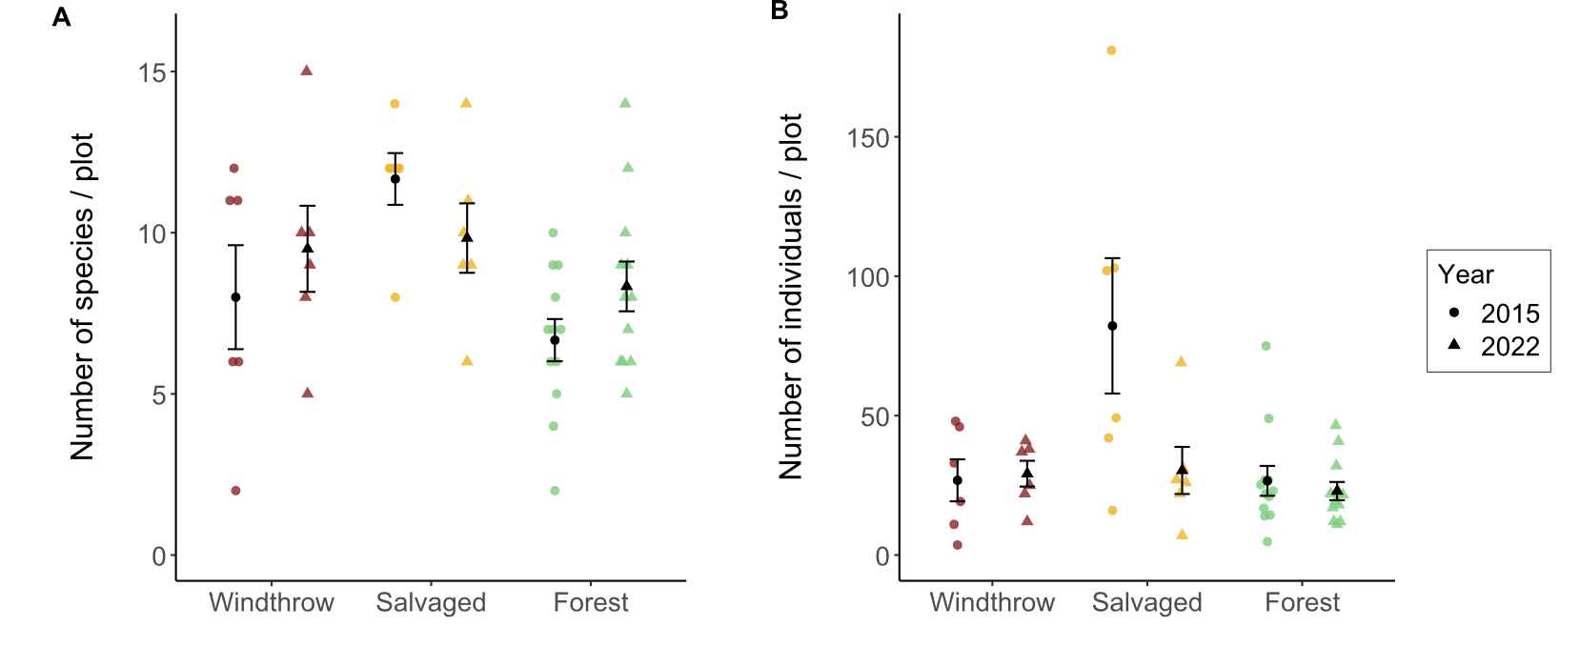

Figure 2.2. Total species richness (A) and activity-abundance (B) of ground beetles collected in windthrow, salvaged, and undisturbed forest in 2015 and 2022 at Powdermill Nature Reserve, Rector, Westmoreland County, Pennsylvania, USA. Bar height is the group mean, and whiskers indicate the standard error of the mean. In (A), the effect of treatment was significant. In (B), there were significant effects found for treatment and for treatment*year interaction. (Table 2.3).

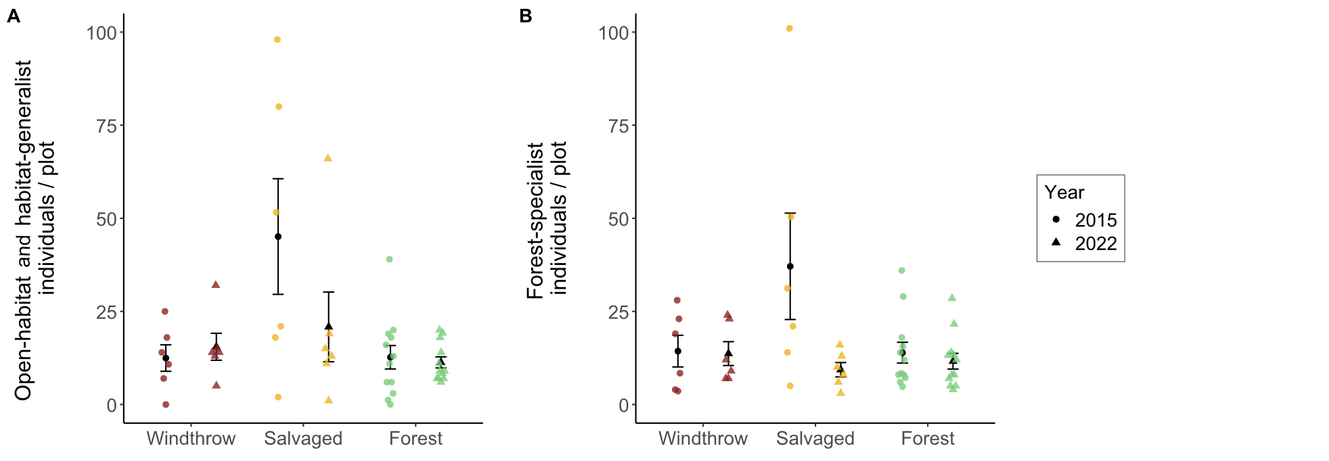
Figure 2.3. Activity-abundance of open-habitat and habitat-generalist ground beetle species (A) and forest-specialist species (B) collected in windthrow, salvaged, and undisturbed forest in 2015 and 2022 at Powdermill Nature Reserve, Rector, Westmoreland County, Pennsylvania, USA. The habitat affinity information was collected from Larochelle and Larivière (2003). Bar height is the group mean, and whiskers indicate the standard error of the mean. For (A), there was a significant effect of treatment, while for (B), there were no significant effects detected (Table 2.3).

Table 2.2. Total trap catch of ground beetle species (Coleoptera: Carabidae) collected via pitfall traps at Powdermill Nature Reserve, Rector, Westmoreland County, Pennsylvania, USA. Sampling occurred from 27 May to 17 August, 2015, and from 1 June to 23 August, 2022. The columns of the table are tribe, species (including authority), code (referring to species codes in Figure B.2 and B.3), 2015 (counts), 2022 (counts), and total (counts).
Tribe | Species | Code | 2015 | 2022 | Total
Notiophilini
 | Notiophilus aeneus (Herbst) | No.ae | 2 | 1 | 3
Cychrini
 | Sphaeroderus canadensis | Sp.ca | 35 | 7 | 42
 | Sphaeroderus stenostomus | Sp.st | 76 | 82 | 158
 | Scaphinotus viduus (Dejean) | Sc.vi | 1 | 1 | 2
 | Scaphinotus imperfectus (Horn) | Sc.im | 0 | 3 | 3
Carabini
 | Carabus goryi Dejean | Ca.go | 66 | 33 | 99
Pterostichini
 | Lophoglossus scrutator (LeConte) | Lo.sc | 0 | 1 | 1
 | Pterostichus mutus (Say) | Pt.mu | 1 | 0 | 1
 | Pterostichus corvinus (Dejean) | Pt.co | 6 | 0 | 6
 | Pterostichus sayanus Csiki | Pt.sa | 0 | 1 | 1
 | Pterostichus coracinus (Newman) | Pt.co | 28 | 14 | 42
 | Pterostichus melanarius (Illiger) | Pt.me | 1 | 0 | 1
 | Pterostichus lachrymosus (Newman) | Pt.la | 27 | 45 | 72
 | Pterostichus stygicus (Say) | Pt.st | 62 | 70 | 132
 | Pterostichus hamiltoni Horn | Pt.ha | 0 | 1 | 1
 | Pterostichus moestus (Say) | Pt.mo | 185 | 47 | 232
 | Pterostichus diligendus (Chaudoir) | Pt.di | 1 | 1 | 2
 | Pterostichus rostratus (Newman) | Pt.ro | 36 | 22 | 58
 | Pterostichus adoxus (Say) | Pt.ad | 19 | 80 | 99
 | Pterostichus tristis (Dejean) | Pt.tr | 10 | 31 | 41
 | Cyclotrachelus fucatus (Freitag) | Cy.fu | 5 | 1 | 6
 | Cyclotrachelus convivus (LeConte) | Cy.co | 1 | 0 | 1
 | Cyclotrachelus sigillatus (Say) | Cy.si | 22 | 52 | 74
Chlaeniini
 | Chlaenius emarginatus Say | Ch.em | 137 | 25 | 162
 | Chlaenius laticollis Say | Ch.la | 2 | 0 | 2

Continued

Table 2.2 Continued

Tribe | Species | Code | 2015 | 2022 | Total
Licinini
 | Dicaelus politus Dejean | Di.po | 54 | 13 | 67
 | Dicaelus teter Bonelli | Di.te | 68 | 10 | 78
Harpalini
 | Notiobia nitidipennis (LeConte) | No.ni | 6 | 0 | 6
 | Anisodactylus harrisii LeConte | An.ha | 2 | 1 | 3
 | Anisodactylus melanopus (Haldeman) | An.me | 1 | 0 | 1
 | Anisodactylus nigerrimus (Dejean) | An.ni | 3 | 5 | 8
 | Amphasia interstitialis (Say) | Am.in | 6 | 0 | 6
 | Agonoleptus thoracicus (Casey) | Ag.th | 0 | 1 | 1
 | Harpalus spadiceus Dejean | Ha.sp | 1 | 11 | 12
 | Trichotichnus autumnalis (Say) | Tr.au | 10 | 2 | 12
Sphodrini
 | Pseudamara arenaria (LeConte) | Ps.ar | 2 | 1 | 3
Platynini
 | Olisthopus parmatus (Say) | Ol.pa | 3 | 2 | 5
 | Agonum ferreum Haldeman | Ag.fe | 1 | 0 | 1
 | Agonum fidele Casey | Ag.fi | 31 | 3 | 34
 | Agonum retractum LeConte | Ag.re | 1 | 0 | 1
 | Platynus decentis (Say) | Pl.de | 0 | 1 | 1
 | Platynus tenuicollis (LeConte) | Pl.te | 3 | 5 | 8
 | Platynus angustatus Dejean | Pl.an | 19 | 17 | 36
Lebiini
 | Cymindis limbata Dejean | Cy.li | 0 | 1 | 1
 | Cymindis platicollis (Say) | Cy.pl | 0 | 1 | 1
 | Apenes lucidula (Dejean) | Ap.lu | 0 | 8 | 8
Galeritini
 | Galerita bicolor (Drury) | Ga.bi | 0 | 3 | 3
Total |  |  | 934 | 603 | 1537

The principal components analysis (PCA) of the eight numerical traits generated a set of axes, of which the first four axes together explained 89% of the variance (Table B.2). The first PC axis (39% of the variance) was associated with proportionally shorter antennae, shorter rear legs, and wider pronotum (Figure B.2). The second axis (26% of the variance) was associated with proportionally longer eyes, higher eye protrusion, and shorter body length. The third axis (14% of the variance) was associated with proportionally shorter rear trochanter and wider abdomen (Figure S4). The fourth axis (11% of the variance) was associated with proportionally wider abdomen and longer body length.
A subset of functional traits showed differences among treatments, but functional alpha-diversity was similar among forest management treatments and across years (Tables 2.3-2.4). The CWM body length was greater for forest plots than salvaged plots, while windthrow plots were intermediate (Fig. 2.4A). This indicates that species of larger body length made up a higher proportion of trap captures in forest plots than salvaged plots. When we examined morphological traits of the eyes and antenna relative to body length, we found that CWM eye length was greater for salvaged plots than windthrow or forest plots (Fig. 5C). Thus, species abundant in salvaged plots had longer eyes. However, we did not detect differences in CWM antenna length (Fig. 2.4E). When considering the morphological traits associated with locomotion strategy, we found that CWM trochanter length was greater for salvaged plots than windthrow or forest (Fig. 2.4D). This means species common in salvaged plots tended to have a longer rear trochanters, versus species common in windthrow or forest plots. Flight capable species were more common in salvaged plots in 2015, but this pattern disappeared by 2022 (Fig. 2.4B). No patterns were detected for water affinity (Fig. 2.4F).

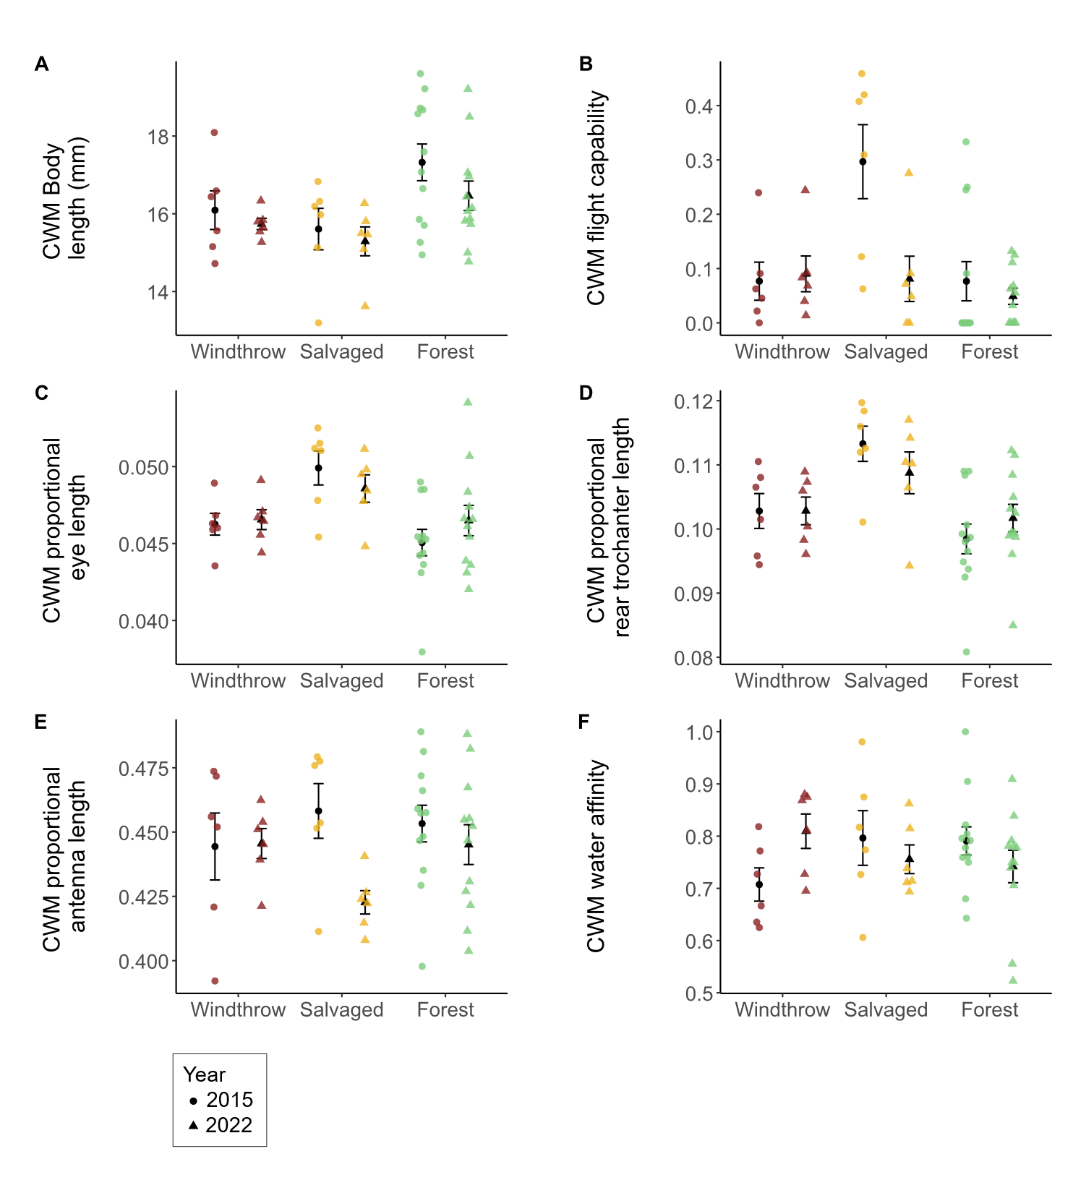
Figure 2.4. Community-weighted mean (CWM) traits of ground beetles collected in windthrow, salvaged, and undisturbed forest plots in 2015 and 2022. Circular points are observations from 2015, while triangles are observations from 2022. (A) CWM body length, measured as the sum of head length, pronotum length, and elytron length. (B) CWM flight capability, as indicated in the literature (Larochelle and Larivière 2003). Values closer to 1 indicate that a higher proportion of individuals collected were identified as flight-capable species. (C) CWM eye length (posterior to anterior edge of eye) standardized to body length. (D) CWM meta-trochanter length standardized to body length. (E) CWM antenna length standardized to body length. (F) CWM water affinity, as indicated in the literature (Larochelle and Larivière 2003). Values closer to 1 indicate that a higher proportion of individuals collected belonged to species which prefer wet soil or live near water. A significant effect of forest management treatment was found for A-D, while no significant effects were found for E-F.

Table 2.3. Main effects of forest management treatments (windthrow, salvaged, undisturbed forest) and year (2015, 2022) on activity-abundance, species richness, species diversity, community-weighted means (CWM) for individual traits, and functional diversity for ground beetles collected at Powdermill Nature Reserve, Rector, Westmoreland County, Pennsylvania, USA. The model type column indicates if the model was a standard linear model (LM), a linear mixed-effects model with transect included as a random effect (LMM), or a generalized linear model with Poisson errors (GLM). Dashes indicate that the p-value is above 0.10. Patterns with a p-value below 0.05 are bolded. Beetles were collected between 27 May to 17 August, 2015, and from 1 June to 23 August, 2022.
Response variable | Model  type | Treatment  (Windthrow, Salvaged, Forest) |  | Year (2015, 2022) |  | Treatment*Year interaction
 |  | Statistic | p | Statistic | p | Statistic | p
Total activity-abundance | LMM* | F= 5.7 | 0.007 | F=1.9 | - | F=4.5 | 0.018
Activity abundance of open-habitat and habitat-generalist species | LMM* | F=3.6 | 0.037 | F=0.01 | - | F=2.4 | -
Activity abundance of forest-specialist species | LMM* | F=0.7 | - | F=3.4 | 0.075 | F=2.7 | 0.079
Species richness | GLM | X²=11.5 | 0.003 | X²=2.2 | - | X²=3.2 | -
Shannon diversity | LMM | F= 1.0 | - | F= 1.3 | - | F= 0.2 | -
*: a log transformation was done on the response variable to improve the model’s satisfaction of assumptions

Continued

Table 2.3 Continued

Response variable | Model  type | Treatment  (Windthrow, Salvaged, Forest) |  | Year (2015, 2022) |  | Treatment*Year interaction
 |  | Statistic | p | Statistic | p | Statistic | p
Functional alpha-diversity | LM | F=0.4 | - | F= 0.001 | - | F= 1.5 | -
CWM Body length | LM | F=5.8 | 0.006 | F=2.6 | - | F=0.3 | -
CWM Standardized antenna length | LMM | F=0.6 | - | F=3.9 | 0.056 | F=2.0 | -
CWM Standardized rear leg length | LMM | F=0.4 | - | F=1.6 | - | F=1.9 | -
CWM Standardized eye length | LMM | F=8.1 | 0.001 | F=0.03 | - | F=1.3 | -
CWM Standardized eye protrusion | LMM | F= 1.9 | - | F= 0.3 | - | F= 0.9 | -
CWM Standardized pronotum width | LMM | F= 1.2 | - | F= 1.2 | - | F= 0.05 | -

Continued

Table 2.3 Continued

Response variable | Model  type | Treatment  (Windthrow, Salvaged, Forest) |  | Year (2015, 2022) |  | Treatment*Year interaction
 |  | Statistic | p | Statistic | p | Statistic | p
CWM Standardized abdomen width | LMM | F= 0.4 | - | F= 0.6 | - | F= 0.6 | -
CWM Standardized rear trochanter length | LMM | F= 11.4 | <0.001 | F= 0.05 | - | F= 1.4 | -
CWM Water affinity | LM | F=0.1 | - | F= 0.1 | - | F= 2.7 | 0.082
CWM Flight capability | LMM* | F= 5.7 | 0.007 | F= 3.5 | 0.068 | F= 3.9 | 0.028
*: a log transformation was done on the response variable to improve the model’s satisfaction of assumptions

Table 2.4. Means (± standard errors) of the response variables for ground beetle biodiversity. The columns list the response variable, followed by the unit, then the year, and then there are columns for the group means for windthrow, salvaged, and forest.
 |  | Unit |  | Year | Windthrow | Salvaged | Forest
Sample size |  | Plots |  | 2015 | n=6 | n=6 | n=12
 |  |  |  | 2022 | n=6 | n=6 | n=12
Total activity- |  | Beetles per 84 trap days |  | 2015 | 26.8 ± 7.5 | 82.2 ± 24.3 | 26.6 ± 5.4
abundance |  |  |  | 2022 | 29.2 ± 4.6 | 30.3 ± 8.4 | 22.9 ± 3.3
Activity abundance of |  | Beetles per 84 trap days |  | 2015 | 0 ± 0 | 0.90 ± 0.32 | 0 ± 0
open-habitat species |  |  |  | 2022 | 0 ± 0 | 0.67 ± 0.67 | 0.23 ± 0.15
Activity abundance of |  | Beetles per 84 trap days |  | 2015 | 12.4 ± 3.6 | 44.2 ± 15.4 | 12.7 ± 3.1
eurytopic species |  |  |  | 2022 | 15.5 ± 3.6 | 20.2 ± 8.7 | 11.1 ± 1.4
Activity abundance of |  | Beetles per 84 trap days |  | 2015 | 14.3 ± 4.2 | 37.1 ± 14.3 | 13.9 ± 2.8
forest-specialist species |  |  |  | 2022 | 13.7 ± 3.2 | 9.3 ± 1.9 | 11.6 ± 2.1
Species richness |  | Number of species |  | 2015 | 8.0 ± 1.6 | 11.7 ± 0.8 | 6.7 ± 0.7
 |  |  |  | 2022 | 9.5 ± 1.3 | 9.8 ± 1.1 | 8.3 ± 0.8
Shannon diversity |  | Effective number of species |  | 2015 | 6.5 ± 1.2 | 6.3 ± 1.0 | 5.1 ± 0.5
 |  |  |  | 2022 | 7.0 ± 0.9 | 6.7 ± 1.0 | 6.4 ± 0.6

Continued

Table 2.4 Continued

 |  | Unit |  | Year | Windthrow | Salvaged | Forest
Functional alpha- |  | Within-plot mean pairwise |  | 2015 | 0.16 ± 0.02 | 0.18 ± 0.01 | 0.15 ± 0.01
diversity |  | distance in trait space |  | 2022 | 0.17 ± 0.01 | 0.16 ± 0.01 | 0.17 ± 0.01
CWM Body length |  | mm |  | 2015 | 16.09 ± 0.50 | 15.61 ± 0.53 | 17.32 ± 0.47
 |  |  |  | 2022 | 15.74 ± 0.15 | 15.29 ± 0.37 | 16.46 ± 0.38
CWM |  | Fraction of body length |  | 2015 | 0.444 ± 0.013 | 0.458 ± 0.011 | 0.453 ± 0.007
antenna length |  |  |  | 2022 | 0.446 ± 0.006 | 0.423 ± 0.005 | 0.445 ± 0.008
CWM |  | Fraction of body length |  | 2015 | 0.731 ± 0.014 | 0.752 ± 0.013 | 0.744 ± 0.013
rear leg length |  |  |  | 2022 | 0.740 ± 0.006 | 0.712 ± 0.008 | 0.739 ± 0.009
CWM eye |  | Fraction of body length |  | 2015 | 0.046 ± 0.001 | 0.05 ± 0.001 | 0.045 ± 0.001
length |  |  |  | 2022 | 0.047 ± 0.001 | 0.049 ± 0.001 | 0.046 ± 0.001
CWM eye |  | Fraction of body length |  | 2015 | 0.052 ± 0.001 | 0.054 ± 0.001 | 0.051 ± 0.001
protrusion |  |  |  | 2022 | 0.052 ± 0.000 | 0.053 ± 0.001 | 0.052 ± 0.001
CWM |  | Fraction of body length |  | 2015 | 0.263 ± 0.002 | 0.265 ± 0.002 | 0.262 ± 0.003
pronotum width |  |  |  | 2022 | 0.265 ± 0.001 | 0.268 ± 0.002 | 0.264 ± 0.001

Continued

Table 2.4 Continued

 |  | Unit |  | Year | Windthrow | Salvaged | Forest
CWM |  | Fraction of body length |  | 2015 | 0.349 ± 0.006 | 0.351 ± 0.005 | 0.353 ± 0.004
abdomen width |  |  |  | 2022 | 0.357 ± 0.003 | 0.349 ± 0.003 | 0.354 ± 0.003
CWM rear |  | Fraction of body length |  | 2015 | 0.103 ± 0.003 | 0.113 ± 0.003 | 0.098 ± 0.002
trochanter length |  |  |  | 2022 | 0.103 ± 0.002 | 0.109 ± 0.003 | 0.102 ± 0.002
CWM Water affinity |  | 0, 0.5, or 1 |  | 2015 | 0.71 ± 0.03 | 0.80 ± 0.05 | 0.79 ± 0.03
 |  |  |  | 2022 | 0.81 ± 0.03 | 0.76 ± 0.03 | 0.74 ± 0.03
CWM Flight capability |  | 0, 0.5, or 1 |  | 2015 | 0.08 ± 0.04 | 0.30 ± 0.07 | 0.08 ± 0.04
 |  |  |  | 2022 | 0.09 ± 0.03 | 0.08 ± 0.04 | 0.05 ± 0.01

The taxonomic and functional composition of ground beetle communities differed among forest management treatments. Ground beetle communities in salvaged plots were taxonomically distinct from undisturbed forest, and taxonomic composition changed over time from 2015 to 2022 (F=3.8, p<0.001; Fig. 2.5A). Functional composition showed an interaction between treatment and year, whereby salvaged plots differed from windthrow and undisturbed forest in 2015, but these differences were not detected in 2022 (F=1.3, p=0.046; Fig. 2.5B). Neither treatment groups nor years differed significantly in dispersion from their spatial medians (p>0.10 in all cases).

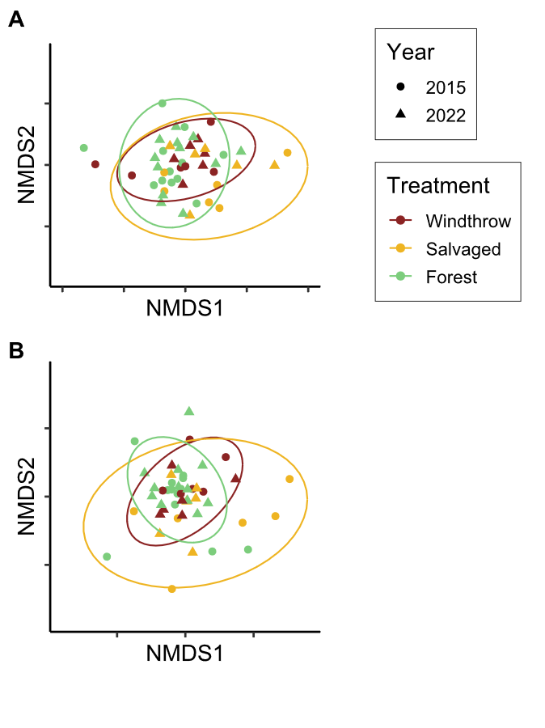
Figure 2.5. Nonmetric multidimensional scaling (NMDS) ordinations of ground beetle communities in taxonomic space (A) and functional trait space (B). Each point is a plot in a given year; shape of the point indicates the year the community was sampled, while color indicates the forest management treatment. The NMDS ordinations resulted in stress values of 0.224 for taxonomic beta-diversity and 0.181 for functional beta-diversity.

The forest floor environment changed among the forest management treatments over time (Table 2.5). Canopy openness varied by treatment (F=47.2, p<0.001), year (F=45.9, p<0.001), and their interaction (F=19.9, p<0.001). In 2015, canopy openness was higher in salvaged plots than windthrow or undisturbed forest, but the magnitude of these treatment differences decreased in 2022, because the canopy closed over time following salvage-logging. Percentage cover of understory vegetation varied by treatment (F=15.6, p<0.001) and treatment*year interaction (F=5.7, p=0.007). In 2015, percentage cover of understory vegetation was higher in salvaged plots than windthrow, and windthrow had higher vegetation cover than forest, but these differences became less pronounced by 2022. Meanwhile, percentage cover of leaf litter showed the opposite pattern. In 2015, salvaged plots had the lowest leaf litter cover, followed by windthrow plots and then forest with the highest leaf litter cover (F=20.0, p<0.001). By 2022, these differences had lessened in magnitude, leading to an interaction between treatment and year (F=8.8, p=0.001). Soil moisture was similar among forest management treatments, both in 2015 (F=0.08, p>0.10) and in 2022 (F=0.2, p>0.10).

Table ___ Means (± standard errors) of the environmental variables in the understory. The columns list the environmental variable, followed by the unit, then the year, and then there are columns for the group means for windthrow, salvaged, and forest.
Environmental variable |  | Unit |  | Year | Forest | Salvaged | Windthrow
Canopy openness |  | 0-100% |  | 2015 | 9.1 ± 0.4 | 82.3 ± 3.4 | 13.7 ± 2.5
 |  |  |  | 2022 | 7.7 ± 0.5 | 19.7 ± 10.8 | 9.1 ± 1.3
Ground-level vegetation |  | 0-100% |  | 2015 | 21.6 ± 2.8 | 73.0 ± 6.0 | 42.1 ± 10.4
percentage cover |  |  |  | 2022 | 35.1 ± 4.2 | 47.7 ± 11.3 | 41.9 ± 6.7
Leaf litter percentage cover |  | 0-100% |  | 2015 | 61.2 ± 3.6 | 5.2 ± 3.5 | 35.4 ± 7.3
 |  |  |  | 2022 | 43.1 ± 4.5 | 31.5 ± 9.5 | 39.6 ± 5.8
Soil moisture$ |  | 0-1.129 |  | 2015 | 0.59 ± 0.04 | 0.61 ± 0.07 | 0.60 ± 0.04
 |  | 0-100% |  | 2022 | 44.8 ± 3.5 | 47.6 ± 2.5 | 48.7 ± 7.4
$: A different soil sensor was used in 2022 than was used in 2015, so readings are only comparable between treatments within a year.
Discussion
This study investigated the effects of disturbance caused by wind and subsequent salvage logging on ground beetle communities over time. We found that ground beetles differed both taxonomically and functionally between windthrow and salvaged forest, consistent with other studies (Koivula and Spence 2006, Gandhi et al. 2008). Salvage-logging, which removed all standing and downed trees, supported ground beetle communities that were distinct in species and trait composition, compared to windthrow and undisturbed forest which were more similar to one another. Although differences between treatments were largest two years after salvaging in 2015, some differences in species and traits persisted in 2022, nine years after salvaging. These findings suggest that the impacts of salvage logging after a natural disturbance continue to affect forest invertebrates for more than a decade, even as tree regeneration occurs.
Ground beetle activity-abundance, species richness, and community composition were similar among windthrow and undisturbed forest in 2015 and 2022. This finding was inconsistent with our hypothesis that ground beetle alpha-diversity would increase in unsalvaged windthrow relative to undisturbed forest. Other studies have found slightly elevated ground beetle alpha-diversity and altered community composition in windthrow relative to reference forest (Gandhi et al. 2008, Sklodowski and Garbalinska 2011, Barber and Widick 2017). Wind from strong storms increases standing and downed woody debris, changes abiotic conditions on the soil surface, and stimulates the growth of ground-level vegetation, all of which can alter the structure and composition of arthropod communities (Urbanovicova et al. 2014, Wermelinger et al. 2017). Some of these environmental changes were observed in our study, including increased cover of ground level vegetation and decreased cover of leaf litter. However, instead of a complete reorganization of the ground beetle community, windthrows commonly support many of the same species found in undisturbed forest (Lee et al. 2017). Similarly, our study documented the persistence of forest-specialists in unsalvaged windthrows rather than a pronounced influx of generalists or open-habitat species.
Windthrow followed by salvage-logging resulted in distinct ground beetle communities and elevated species richness relative to undisturbed forest. Habitat-generalists increased in abundance two years after salvaging, altering ground beetle community composition, which supports our initial hypothesis. At nine years after salvaging, ground beetle communities remained taxonomically distinct, suggesting that legacies of windthrow were altered by the logging process. Our results align with many studies of salvage-logging and green-logging, where complete canopy removal resulted in an initial influx of flight-capable species (Pearce et al. 2003, Niemelä et al. 2007, Silverman et al. 2008, Gandhi et al. 2008). We observed an influx of habitat generalists such as C. emarginatus, but open-habitat specialists from the genera Amara and Harpalus were not present, in contrast to other studies (Pearce et al. 2003, Silverman et al. 2008, Riley and Browne 2011). This finding may reflect the surrounding landscape, which is mostly forested and likely did not support source populations of open-habitat species. We also found some forest-specialists, such as P. moestus, thrived initially in salvage-logged habitat, which may indicate their ability to tolerate altered abiotic conditions (Riley and Browne 2011), adopt new food sources (Lee et al. 2017), utilize any rapidly decomposing branches left by salvaging (Hamilton 1884, Thorn et al. 2014), or move between salvaged and unsalvaged habitat during different times of the year (Ohwaki et al. 2015). However, salvaged habitat after nine years supported mostly habitat-generalists such as P. stygicus, suggesting that logging may have reduced the woody debris resources necessary for certain species (Gore and Patterson III 1986, Larochelle and Larivière 2003, Pearce et al. 2003).
Contrary to our hypothesis, we found that functional alpha-diversity was similar among forest management treatments and across years, despite the increase in species richness after salvaging. We expected that the influx of open-habitat species and habitat-generalists following windthrow and salvage-logging would increase functional diversity due to the presence of novel traits such as flight capability or traits associated with specialized modes of feeding (Lee et al. 2017, Nardi et al. 2022). While functional alpha-diversity did not differ, functional beta-diversity between forest management treatments supported our hypothesis. Ground beetle communities in salvage-logged forest were functionally distinct from windthrow and undisturbed forest in 2015. The environmental conditions within salvaged plots, including higher light levels, lower leaf litter depth (Greenberg and Forrest 2003), temperature extremes (Urbanovicova et al. 2014), altered vegetation (Spicer et al. 2023), and changes in prey types (Wermelinger et al. 2017) can act as filters that select for a different suite of functional traits (Bauer and Kredler 1993, Inward et al. 2011, Ng et al. 2018, Sultaire et al. 2021). Species common in salvaged forests had proportionally longer eyes and rear trochanters in both years, and were more flight capable in 2015, partially supporting our hypothesis. Larger eye size can relate to open habitat preference, diurnal activity, and visual-hunting strategy (Bauer and Kredler 1993, Ribera et al. 1999, Talarico et al. 2007). Species with larger rear trochanters can expand crevices between layers of substrate, whereas species with shorter rear trochanters tend to walk or run on the surface (Evans 1977, Forsythe 1981). Further research could investigate why salvage-logging favored species with longer trochanters, even though salvaged forest tended to have lower leaf litter cover and higher vegetation cover. The abundance of flight-capable species often increases in the first few years after disturbance, then decreases over time with forest regeneration (Sklodowski and Garbalinska 2011, Riley and Browne 2011). We found that salvage-logging favored flight capable species in 2015, but not in 2022, which may reflect the rapid tree regeneration occurring in salvaged forest (Curtze et al. 2018). Finally, species common in undisturbed forest tended to have longer bodies, which may reflect that larger forest-specialists can decline in disturbed forests (Sklodowski and Garbalinska 2011).
The process of salvage-logging following a natural disturbance such as wind can alter important biological legacies that shape short- and long-term recovery in forests. These legacies include the size-distribution of tree seedlings (Slyder et al. 2020), the size, age, and microclimate around downed woody debris (Thorn et al. 2014), and the abundance and richness of herbaceous plants in the understory (Elliott et al. 2002, Spicer et al. 2023). Using ground beetles as environmental indicators, we documented shifts in community composition that occurred due to salvage-logging. Our results suggest that habitat generalists benefitted from salvaging, but some species with specialized modes of feeding were disadvantaged (Sultaire et al. 2021). Furthermore, we saw larger differences in community composition than we did in alpha-diversity, suggesting that species turnover occurred among windthrow, salvaged, and undisturbed forest patches, ultimately supporting increased landscape-level diversity. Finally, differences between disturbances (for example, in taxonomic composition and CWM meta-trochanter length) persisted even after nine years, highlighting the importance of maintaining biological legacies in the landscape following disturbance in forests. These findings suggest that conservation-minded land managers should leave a portion of windthrow stands unsalvaged to conserve ground beetle biodiversity in the long term.

References

Barber, N. A., and W. L. Widick. 2017. Localized Effects of Tornado Damage on Ground Beetle Communities and Vegetation in a Forested Preserve. Natural Areas Journal 37:489–496.
Barton, P. S., H. Gibb, A. D. Manning, D. B. Lindenmayer, and S. A. Cunningham. 2011. Morphological traits as predictors of diet and microhabitat use in a diverse beetle assemblage. Biological Journal of the Linnean Society 102:301–310.
Bates, D., M. Mächler, B. Bolker, and S. Walker. 2015. Fitting Linear Mixed-Effects Models Using lme4. Journal of Statistical Software 67.
Bauer, T., and M. Kredler. 1993. Morphology of the compound eyes as an indicator of life-style in carabid beetles. Canadian Journal of Zoology 71:799–810.
Baulechner, D., F. Jauker, T. A. Neubauer, and V. Wolters. 2020. Convergent evolution of specialized generalists: Implications for phylogenetic and functional diversity of carabid feeding groups. Ecology and Evolution 10:11100–11110.
Bousquet, Y. 2010. Illustrated identification guide to adults and larvae of northeastern North American ground beetles: Coleoptera : Carabidae. Pensoft, Sofia.
Bousquet, Y. 2012. Catalogue of Geadephaga (Coleoptera: Adephaga) of America, north of Mexico. ZooKeys 245:1–1722.
Bousquet, Y., and P. Messer. 2010. Redescription of Stenolophus thoracicus Casey (Coleoptera, Carabidae, Harpalini), a valid species. ZooKeys 53:25–31.
Browne, R., S. Maveety, L. Cooper, and K. Riley. 2014. Ground Beetle (Coleoptera: Carabidae) Species Composition in the Southern Appalachian Mountains. Southeastern Naturalist 13:407–422.
Calinger, K., E. Calhoon, H. Chang, J. Whitacre, J. Wenzel, L. Comita, and S. Queenborough. 2015. Historic Mining and Agriculture as Indicators of Occurrence and Abundance of Widespread Invasive Plant Species. PLOS ONE 10:e0128161.
Chao, A., and C. Chiu. 2016. Species Richness: Estimation and Comparison. Pages 1–26 in R. S. Kenett, N. T. Longford, W. W. Piegorsch, and F. Ruggeri, editors. Wiley StatsRef: Statistics Reference Online. First edition. Wiley.
Chao, A., K. H. Ma, T. C. Hsieh, and C. Chiu. 2016. SpadeR: Species-Richness Prediction and Diversity Estimation with R.
Curtze, A. C., T. A. Carlo, and J. W. Wenzel. 2018. The Effects of a Tornado Disturbance and a Salvaged Timber Extraction on the Seed-Rain and Recruitment Community of an Eastern Temperate Deciduous Forest. Northeastern Naturalist 25:627.
Elliott, K. J., S. L. Hitchcock, and L. Krueger. 2002. Vegetation Response to Large Scale Disturbance in a Southern Appalachian Forest: Hurricane Opal and Salvage Logging. Journal of the Torrey Botanical Society 129:48.
Erwin, T. L. 1979. Thoughts on the Evolutionary History of Ground Beetles: Hypotheses Generated from Comparative Faunal Analyses of Lowland Forest Sites in Temperate and Tropical Regions. Pages 539–592 in T. L. Erwin, G. E. Ball, D. R. Whitehead, and A. L. Halpern, editors. Carabid Beetles: Their Evolution, Natural History, and Classification. Springer Netherlands, Dordrecht.
Evans, M. E. G. 1977. Locomotion in the Coleoptera Adephaga, especially Carabidae. Journal of Zoology 181:189–226.
Fischer, A., P. Marshall, and A. Camp. 2013. Disturbances in deciduous temperate forest ecosystems of the northern hemisphere: their effects on both recent and future forest development. Biodiversity and Conservation 22:1863–1893.
Forsythe, T. G. 1981. Running and Pushing in Relationship to Hind Leg Structure in Some Carabidae (Coleoptera). The Coleopterists Bulletin 35:353–378.
Forsythe, T. G. 1991. Feeding and locomotory functions in relation to body form in five species of ground beetle (Coleoptera: Carabidae). Journal of Zoology 223:233–263.
Fountain-Jones, N. M., S. C. Baker, and G. J. Jordan. 2015. Moving beyond the guild concept: developing a practical functional trait framework for terrestrial beetles. Ecological Entomology 40:1–13.
Fox, J., and S. Weisberg. 2019. An {R} Companion to Applied Regression. Sage, Thousand Oaks {CA}.
Freitag, R. 1969. A revision of the species of the genus Evarthrus LeConte (Coleoptera: Carabidae). Quaestiones Entomologicae 5:88–212.
Gandhi, K. J. K., D. W. Gilmore, S. A. Katovich, W. J. Mattson, J. C. Zasada, and S. J. Seybold. 2008. Catastrophic windstorm and fuel-reduction treatments alter ground beetle (Coleoptera: Carabidae) assemblages in a North American sub-boreal forest. Forest Ecology and Management 256:1104–1123.
Gore, J. A., and W. A. Patterson III. 1986. Mass of downed wood in northern hardwood forests in New Hampshire: potential effects of forest management. Canadian Journal of Forest Research 16:335–339.
Greenberg, C. H., and T. G. Forrest. 2003. Seasonal abundance of ground-occuring macroarthropods in forest and canopy gaps in the southern Appalachians. Southeastern Naturalist 2:591–608.
Hamilton, J. 1884. The survival of the fittest among certain species of Pterostichus as deduced from their habits. The Canadian Entomologist 16:73–77.
Harden, C. W., and F. G. Guarnieri. 2017. Illustrated Key and Photo Atlas of the Snail-eating Ground Beetles in the Genus Scaphinotus Dejean (Coleoptera: Carabidae: Cychrini) Occurring in the Mid-Atlantic Region. The Maryland Entomologist 7:16–34.
Hunting, W. 2013. A taxonomic revision of the Cymindis (Pinacodera) limbata species group (Coleoptera, Carabidae, Lebiini), including description of a new species from Florida, U.S.A. ZooKeys 259:1–73.
Inward, D. J. G., R. G. Davies, C. Pergande, A. J. Denham, and A. P. Vogler. 2011. Local and regional ecological morphology of dung beetle assemblages across four biogeographic regions: Ecological morphology of dung beetle assemblages. Journal of Biogeography 38:1668–1682.
Kembel, S. W., P. D. Cowan, M. R. Helmus, W. K. Cornwell, H. Morlon, D. D. Ackerly, S. P. Blomberg, and C. O. Webb. 2010. Picante: R tools for integrating phylogenies and ecology. Bioinformatics 26:1463–1464.
Koivula, M. 2011. Useful model organisms, indicators, or both? Ground beetles (Coleoptera, Carabidae) reflecting environmental conditions. ZooKeys 100:287–317.
Koivula, M., and J. R. Spence. 2006. Effects of post-fire salvage logging on boreal mixed-wood ground beetle assemblages (Coleoptera, Carabidae). Forest Ecology and Management 236:102–112.
Kuznetsova, A., P. B. Brockhoff, and R. H. B. Christensen. 2017. lmerTest Package: Tests in Linear Mixed Effects Models. Journal of Statistical Software 82.
Laliberte, E., P. Legendre, and B. Shipley. 2014. FD: measuring functional diversity from multiple traits, and other tools for functional ecology. R.
Lambeets, K., M. L. Vandegehuchte, J. Maelfait, and D. Bonte. 2008. Understanding the impact of flooding on trait‐displacements and shifts in assemblage structure of predatory arthropods on river banks. Journal of Animal Ecology 77:1162–1174.
Langor, D. W., and J. R. Spence. 2006. Arthropods as ecological indicators of sustainability in Canadian forests. The Forestry Chronicle 82:344–350.
Larochelle, A., and M.-C. Larivière. 2003. A natural history of the ground-beetles (Coleoptera: Carabidae) of America north of Mexico. Pensoft Publ, Sofia.
Lee, C. M., T.-S. Kwon, and K. Cheon. 2017. Response of ground beetles (Coleoptera: Carabidae) to forest gaps formed by a typhoon in a red pine forest at Gwangneung Forest, Republic of Korea. Journal of Forestry Research 28:173–181.
Lenth, R. V. 2024. emmeans: Estimated Marginal Means, aka Least-Squares Means. R.
Li, D. 2018. hillR: taxonomic, functional, and phylogenetic diversity and similarity through Hill Numbers. Journal of Open Source Software 3:1041.
Lindenmayer, D., P. J. Burton, and J. F. Franklin. 2012. Salvage logging and its ecological consequences. Island Press, United States.
Lindroth, C. H. 1961. The Ground-beetles of Canada and Alaska.
Lundgren, J., and K. McCravy. 2011. Carabid beetles (Coleoptera: Carabidae) of the Midwestern United States: a review and synthesis of recent research. Terrestrial Arthropod Reviews 4:63–94.
Martinez Arbizu, P. 2017. pairwiseAdonis: Pairwise Multilevel Comparison using Adonis. R.
McNabb, D. H., A. D. Startsev, and H. Nguyen. 2001. Soil Wetness and Traffic Level Effects on Bulk Density and Air‐Filled Porosity of Compacted Boreal Forest Soils. Soil Science Society of America Journal 65:1238–1247.
Murphy, S. J., L. D. Audino, J. Whitacre, J. L. Eck, J. W. Wenzel, S. A. Queenborough, and L. S. Comita. 2015. Species associations structured by environment and land‐use history promote beta‐diversity in a temperate forest. Ecology 96:705–715.
Nardi, D., F. Giannone, and L. Marini. 2022. Short-term response of ground-dwelling arthropods to storm-related disturbances is mediated by topography and dispersal. Basic and Applied Ecology 65:86–95.
National Centers for Environmental Information: Past Weather. 2012, 2022. . National Oceanic and Atmospheric Administration.
Ng, K., P. S. Barton, W. Blanchard, M. J. Evans, D. B. Lindenmayer, S. Macfadyen, S. McIntyre, and D. A. Driscoll. 2018. Disentangling the effects of farmland use, habitat edges, and vegetation structure on ground beetle morphological traits. Oecologia 188:645–657.
Niemelä, J., M. Koivula, and D. J. Kotze. 2007. The effects of forestry on carabid beetles (Coleoptera: Carabidae) in boreal forests. Journal of Insect Conservation 11:5–18.
Ohwaki, A., Y. Kaneko, and H. Ikeda. 2015. Seasonal variability in the response of ground beetles (Coleoptera: Carabidae) to a forest edge in a heterogeneous agricultural landscape in Japan. European Journal of Entomology 112:135–144.
Oksanen, J., G. Simpson, F. Blanchet, Kindt R, Legendre P, Minchin P, O’Hara R, Solymos P, Stevens M, Szoecs E, Wagner H, Barbour M, Bedward M, Bolker B, Borcard D, Carvalho G, Chirico M, De Caceres, M, Durand S, Evangelista H, FitzJohn R, Friendly M, Furneaux B, Hannigan G, Hill M, Lahti L, McGlinn D, Ouellette M, Ribeiro, and Cunha E, Smith T, Stier A, Ter Braak C, Weedon J. 2024. _vegan: Community Ecology Package_. R.
Pearce, J. L., L. A. Venier, J. McKee, J. Pedlar, and D. McKenney. 2003. Influence of habitat and microhabitat on carabid (Coleoptera: Carabidae) assemblages in four stand types. The Canadian Entomologist 135:337–357.
Perry, K., and D. Herms. 2019. Dynamic Responses of Ground-Dwelling Invertebrate Communities to Disturbance in Forest Ecosystems. Insects 10:61.
Perry, K. I., K. F. Wallin, J. W. Wenzel, and D. A. Herms. 2018. Forest disturbance and arthropods: Small‐scale canopy gaps drive invertebrate community structure and composition. Ecosphere 9:e02463.
Peterson, C. J., and A. D. Leach. 2008. Salvage logging after windthrow alters microsite diversity, abundance and environment, but not vegetation. Forestry 81:361–376.
Phillips, I. D., and T. P. Cobb. 2005. Effects of Habitat Structure and Lid Transparency on Pitfall Catches. Environmental Entomology 34:875–882.
R Core Team. 2024. R: A Language and Environment for Statistical Computing. R Foundation for Statistical Computing, Vienna, Austria.
Ribera, I., S. Dolédec, I. S. Downie, and G. N. Foster. 2001. Effect of Land Disturbance and Stress on Species Traits of Ground Beetle Assemblages. Ecology 82:1112–1129.
Ribera, I., G. N. Foster, I. S. Downie, D. I. McCracken, and V. J. Abernethy. 1999. A comparative study of the morphology and life traits of Scottish ground beetles (Coleoptera, Carabidae). Annales Zoologici Fennici 36:21–37.
Riley, K., and R. Browne. 2011. Changes in ground beetle diversity and community composition in age structured forests (Coleoptera, Carabidae). ZooKeys 147:601–621.
Schammel, L. A., E. J. Holzmueller, J. W. Groninger, C. M. Ruffner, and J. L. Nelson. 2025. Recovering of Biodiversity in Bottomland Hardwood Forests After a Tornado and Salvage Logging in Southern Illinois (USA). Ecologies 6:27.
Seidl, R., D. Thom, M. Kautz, D. Martin-Benito, M. Peltoniemi, G. Vacchiano, J. Wild, D. Ascoli, M. Petr, J. Honkaniemi, M. J. Lexer, V. Trotsiuk, P. Mairota, M. Svoboda, M. Fabrika, T. A. Nagel, and C. P. O. Reyer. 2017. Forest disturbances under climate change. Nature Climate Change 7:395–402.
Silverman, B., D. J. Horn, F. F. Purrington, and K. J. K. Gandhi. 2008. Oil Pipeline Corridor Through an Intact Forest Alters Ground Beetle (Coleoptera: Carabidae) Assemblages in Southeastern Ohio. Environmental Entomology 37:725–733.
Sklodowski, J., and P. Garbalinska. 2011. Ground beetle (Coleoptera, Carabidae) assemblages inhabiting Scots pine stands of Puszcza Piska Forest: six-year responses to a tornado impact. ZooKeys 100:371–392.
Slesak, R. A., C. F. Lenhart, K. N. Brooks, A. W. D’Amato, and B. J. Palik. 2014. Water table response to harvesting and simulated emerald ash borer mortality in black ash wetlands in Minnesota, USA. Canadian Journal of Forest Research 44:961–968.
Slyder, J. B., J. W. Wenzel, A. A. Royo, M. E. Spicer, and W. P. Carson. 2020. Post-windthrow salvage logging increases seedling and understory diversity with little impact on composition immediately after logging. New Forests 51:409–420.
Spicer, M. E., A. A. Royo, J. W. Wenzel, and W. P. Carson. 2023. Understory plant growth forms respond independently to combined natural and anthropogenic disturbances. Forest Ecology and Management 543:121077.
Sultaire, S. M., A. J. Kroll, J. Verschuyl, D. A. Landis, and G. J. Roloff. 2021. Effects of varying retention tree patterns on ground beetle (Coleoptera: Carabidae) taxonomic and functional diversity. Ecosphere 12:e03641.
Swenson, N. G. 2014. Functional and Phylogenetic Ecology in R. Springer New York, New York, NY.
Talarico, F., P. Brandmayr, A. Giglio, A. Massolo, and T. Zetto Brandmayr. 2011. Morphometry of eyes, antennae and wings in three species of Siagona (Coleoptera, Carabidae). ZooKeys 100:203–214.
Talarico, F., M. Romeo, A. Massolo, P. Brandmayr, and T. Zetto. 2007. Morphometry and eye morphology in three species of Carabus (Coleoptera: Carabidae) in relation to habitat demands. Journal of Zoological Systematics and Evolutionary Research 45:33–38.
Thiele, H.-U. 1977. Carabid Beetles in Their Environments. Springer, Berlin, Heidelberg.
Thorn, S., C. Bässler, R. Brandl, P. J. Burton, R. Cahall, J. L. Campbell, J. Castro, C.-Y. Choi, T. Cobb, D. C. Donato, E. Durska, J. B. Fontaine, S. Gauthier, C. Hebert, T. Hothorn, R. L. Hutto, E.-J. Lee, A. B. Leverkus, D. B. Lindenmayer, M. K. Obrist, J. Rost, S. Seibold, R. Seidl, D. Thom, K. Waldron, B. Wermelinger, M.-B. Winter, M. Zmihorski, and J. Müller. 2018. Impacts of salvage logging on biodiversity: A meta-analysis. Journal of Applied Ecology 55:279–289.
Thorn, S., C. Bässler, T. Gottschalk, T. Hothorn, H. Bussler, K. Raffa, and J. Müller. 2014. New Insights into the Consequences of Post-Windthrow Salvage Logging Revealed by Functional Structure of Saproxylic Beetles Assemblages. PLoS ONE 9:e101757.
Urbanovicova, V., D. Miklisová, and A. Mock. 2014. Activity of epigeic arthropods in differently managed windthrown forest stands in the High Tatra Mts. North-western Journal of Zoology 10:337–345.
Venn, S. 2016. To fly or not to fly: Factors influencing the flight capacity of carabid beetles (Coleoptera: Carabidae). European Journal of Entomology 113:587–600.
Wagner, D. L. 2019. Insect Declines in the Anthropocene.
Wermelinger, B., M. Moretti, P. Duelli, T. Lachat, G. B. Pezzatti, and M. K. Obrist. 2017. Impact of windthrow and salvage-logging on taxonomic and functional diversity of forest arthropods. Forest Ecology and Management 391:9–18.
Werner, S. M., and K. F. Raffa. 2000. Effects of forest management practices on the diversity of ground-occurring beetles in mixed northern hardwood forests of the Great Lakes Region. Forest Ecology and Management.

